Cyber Guard: Advanced Machine Learning Model for Anticipating and Preventing Cyber Hacking Breaches Using Random Forest and Multi-layer Perceptron

Abstract
"Cyber-Guard" presents an innovative machine learning framework designed to proactively anticipate and mitigate cyber-hacking breaches. Leveraging the capabilities of Random Forest and Multi-Layer Perceptron (MLP) algorithms, Cyber-Guard employs advanced pattern recognition and classification techniques. Through the synergy of Random Forest's ensemble learning and MLP's deep neural network architecture, Cyber-Guard analyzes data patterns to detect and prevent potential cyber threats. This abstract highlights Cyber-Guard's adaptability. continuous leaming, and robust defense mechanisms, ensuring the protection of critical systems and sensitive data against evolving cyber threats. Cyber hacking breaches prediction is one of the emerging technologies and it has been a quite challenging task to recognize breaches detection and prediction using computer algorithms. Making malware detection more responsive, scalable, and efficient than traditional systems that call for human involvement is the main goal of applying machine learning for breaches detection and prediction. Various types of cyber hacking attacks any of them will harm a person’s information and financial reputation. Data from governmental and non-profit organizations, such as user and company information, may be compromised, posing a risk to their finances and reputation. The information can be collected from websites that can trigger cyberattack. Organizations like the healthcare industry are able to contain sensitive data that needs to be kept discreet and safe. Identity theft, fraud, and other losses may be caused by data breaches. The findings indicate that 70% of breaches affect numerous organizations, including the healthcare industry. The analysis displays the likelihood of a data breach. Due to increased usage of computer applications, the security for host and network is leading to the risk of data breaches. Machine learning methods can be used to find these assaults. By research, machine learning models are utilized to protect the website from security flaws. The dataset can be obtained from the Privacy Rights Clearinghouse. Data breaches can be decreased by educating staff on the use of modern security measures. This can aid in understanding the attacks knowledge and data security. The machine learning models like Random Forest, Decision Tree, k-means and Multilayer Perceptron are used to predict the data breaches.
Keywords: Machine learning framework, cyber-hacking breaches, Random Forest, Multi Layer Perceptron, pattern recognition, cyber threats, data protection

INDEX
CHAPTER 1: INTRODUCTION
1.1 Aim of study
1.2 Objective
1.3 Introduction
1.3.1 Cyber hacking breaches
1.3.2 Key Elements of Cyber Hacking Breaches
1.3.3 Consequences of Cyber Hacking Breaches
1.3.4 Preventing Cyber Hacking Breaches
1.4 Machine Learning
1.4.1 Overview
1.4.2 Machine Learning Algorithms
CHAPTER 2: LITERATURE SURVEY
CHAPTER 3: EXISTING METHOD
3.1 Exiting work
3.2 Disadvantages Of Existing Method
CHAPTER 4: PROPOSED METHOD
4.1 Proposed Work
4.1.1 Model selection:
4.1.2 Data preprocessing:
4.1.3 Feature engineering:
4.1.4 Model selection and training:
4.1.5 Model evalution and selection:.
4.6.7 Data breaches(2004-20021):
4.2 Advantages of proposed work
4.3 Algorithms
4.3.1 Random Forest
4.3.2 Multi-layer Perceptron:
4.3.3 Autoencoder

CHAPTER 5: METHODOLOGY
CHAPTER 6: SYSTEM REQUIREMENTS:
6.1 HARDWARE REQUIREMENTS:
6.2 SOFTWARE REQUIREMENTS:
CHAPTER 7: RESULT
CHAPTER 8: CONCLUSION AND FUTURE SCOPE
REFERENCES
APPENDIX
PYTHON

LIST OF FIGUERS
Figure1.2 Machine learning algorithms
Fig 5.1: System Architecture
Fig.7.1 Upload Dataset
Fig.7.2 Data Preprocessing
Fig.7.3 Dataset train and test
Fig.7.4 Auto Encoder
Fg.7.5 Random forest
Fig.7.6 MLP
Fig.7.7 Threat Detection
Fig.7.8 Algorithms Graph

CHAPTER 1
INTRODUCTION
  - Aim of study
The aim of CyberGuard: Advanced Machine Learning Model for Anticipating and Preventing Cyber Hacking Breaches Using Random Forest and Multi-layer Perceptron is to leverage the strengths of both Random Forest (RF) and Multi-layer Perceptron (MLP) algorithms to create a robust cybersecurity system that can proactively identify, predict, and mitigate potential cyber threats.
1.2 Objective
- Develop and implement a hybrid machine learning model combining Random Forest and Multi-layer Perceptron algorithms to accurately predict and prevent potential cyber hacking breaches by analyzing patterns and anomalies in network traffic, user behavior, and system logs.
- Create a real-time monitoring system capable of continuously scanning network activities and system logs to detect unusual patterns and anomalies indicative of cyber threats, ensuring swift identification and response to potential breaches.
- Utilize the Random Forest algorithm to identify and rank the importance of various features in the dataset, focusing on critical indicators of potential cyber threats and enhancing the overall accuracy and efficiency of the predictive model.
- Implement adaptive learning techniques to enable the system to continuously learn from new data, adapt to emerging threats, and maintain effectiveness over time. Ensure the system is scalable to handle large volumes of data from diverse sources without compromising performance.
- Design the CyberGuard system for easy integration with existing cybersecurity infrastructure, such as firewalls and SIEM systems. Develop user-friendly interfaces and dashboards to allow security professionals to interact with the system, review alerts, and adjust settings effectively.
  - Introduction
"Cyber-Guard" is an innovative machine learning framework designed to anticipate and mitigate cyber-hacking breaches. By leveraging the capabilities of Random Forest and Multi-Layer Perceptron (MLP) algorithms, it utilizes advanced pattern recognition and classification techniques to detect and prevent potential threats. The synergy between Random Forest's ensemble learning and MLP's deep neural network architecture allows Cyber-Guard to analyze complex data patterns accurately. Its adaptability and continuous learning ensure robust defense mechanisms against evolving cyber threats, making it a crucial tool for protecting critical systems and sensitive data.
The emergence of the The digital age has presented opportunities never before possible. for creativity and connectedness. Cyber hacking breaches, on the other hand, are becoming an increasingly dangerous threat as a result of it. Cyberattacks have grown more dangerous and sophisticated in recent years, endangering people, companies, and even entire countries. This project aims to comprehensively investigate and analyze cyber hacking breaches that occurred in the past year. We will delve into the methods, motivations, and impacts of these breaches to gain a deeper understanding of the evolving landscape of cyber threats.
By examining a range of high-profile cases, we intend to identify common vulnerabilities and attack vectors. Our objectives include mapping the tactics employed by hackers, assessing the effectiveness of security measures, and evaluating the financial and reputational costs incurred by victims. Additionally, we will explore the ethical, legal, and regulatory aspects surrounding cyberattacks and data breaches.
This research not only serves as a valuable resource for cybersecurity professionals but also contributes to raising awareness among individuals and organizations about the importance of robust digital security. By shedding light on the ever-evolving world of cyber hacking breaches, we aim to empower stakeholders to fortify their defenses and safeguard their digital assets in an increasingly interconnected world.

- Proactive Threat Detection:
  - Anticipation: Utilize machine learning to predict potential cyber attacks before they occur by analyzing patterns and anomalies in network traffic, user behavior, and system logs.
  - Prevention: Implement measures to stop threats in their tracks, minimizing the risk of data breaches and system compromises.
- Hybrid Model Approach:
  - Random Forest: Employ RF to handle large datasets and identify important features that indicate potential threats. RF’s ability to handle high-dimensional data and its robustness against overfitting make it suitable for identifying complex patterns associated with cyber threats.
  - Multi-layer Perceptron: Use MLP to model non-linear relationships and capture intricate patterns in the data. MLP’s deep learning capabilities enable it to learn from the encoded features and refine predictions.
- Feature Engineering and Selection:
  - Data Processing: Develop techniques to preprocess and clean data, ensuring high-quality inputs for the models. This includes handling missing values, normalizing data, and encoding categorical variables.
  - Feature Importance: Use RF to rank the importance of various features, allowing the system to focus on the most critical indicators of potential breaches.
- Anomaly Detection:
  - Detect unusual patterns that may indicate a cyber attack, such as sudden spikes in network traffic, unusual login times, or atypical user behavior.
  - Use MLP’s ability to learn from complex data to improve the accuracy of anomaly detection, reducing false positives and negatives.
Data breaches are one of the most devastating cyber incidents. The Privacy Rights Clearinghouse [1] reports 7,730 data breaches between 2005 and 2017, accounting for 9,919,228,821 breached records. The Identity Theft Resource Center and Cyber Scout [2] reports 1,093 data breach incidents in 2016, which is 40% higher than the 780 data breach incidents in 2015. The United States Office of Personnel Management (OPM) [3] reports that the personnel information of 4.2 million current and former Federal government employees and the background investigation records of current, former, and prospective federal employees and contractors (including 21.5 million Social Security Numbers) were stolen in 2015. The monetary price incurred by data breaches is also substantial.

Over the years, corporations have increasingly become the target of cyberattacks. Among the ransomware that causes such severe damage, the hackers may employ many attack types. Today, maintaining system security, including the confidentiality of both corporate and personal data, is quite difficult. Millions of cyberattacks per day cause tremendous financial losses. Our study has three main objectives. Using actual cybercrime data, the initial phase is to predict a cybercrime strategy, and the accuracy results are then compared. The second is to examine if the information at hand can be used to predict cybercrime perpetrators.

It is employed to hide a system's data. Information theft is caused by sensitive and highly confidential data as well as poor management. The hackers' techniques might be found in two different methods. One is to move through with legal action, get in touch with the victim, and let them know about the violations [1]. The organizations should be aware of the sorts, trends, and patterns of assaults for the purpose of enabling them to monitor the system. We present a study on the consequences of these kinds of attacks in an effort for managing the prevention of occurring the beaches.

We provide comprehensive study of the breaches that have occurred by the various organizations and financial effect. Because of improvements in information technology, declining prices for memory and storage devices, and the expansion of the digital economy, businesses and governmental organizations now acquire more data every day. Businesses and organizations have the threat of data attacks because of the collecting of personal data on their computers. The Privacy Rights Clearinghouse (PRC) found a large number of records that were exposed due to data breaches between 2005 and 2019.
The organization may face legal action as a result of data breaches that cause financial and reputational harm. Computer networks are used in manufacturing, healthcare, research. This information is transferring every second through network. These attacks are used for profit and destroy the important information and use that for own need which rises the risk of data [2]. Hybrid based detection is used to detect the high false positive rates and low false positive rates. Anomaly based detection analyzes the behavior of traffic, where signature-based detection has the previous attacks records and able to detect the possibilities.
1.3.1 Cyber hacking breaches
Cyber hacking breaches, often simply referred to as "data breaches" or "security breaches," occur when unauthorized individuals or entities gain access to an organization's or individual's digital systems, networks, or data. These breaches can lead to the theft, exposure, or manipulation of sensitive information, causing significant financial, operational, and reputational damage.
A data breach is any security incident in which unauthorized parties access sensitive or confidential information, including personal data (Social Security numbers, bank account numbers, healthcare data) and corporate data (customer records, intellectual property, financial information. cyber hacking breaches represent unauthorized intrusions into computer systems, networks, or data repositories, achieved through exploiting vulnerabilities or bypassing security measures. These breaches can be understood from various theoretical perspectives, including information security, cybersecurity, and cyber-criminology. Here are some key aspects of cyber hacking breaches:

1.3.2 Key Elements of Cyber Hacking Breaches
- Unauthorized Access
  - Intruders gain access to systems, networks, or data without permission. This can be achieved through various methods such as exploiting vulnerabilities, using stolen credentials, or bypassing security measures.
- Data Theft and Exposure
  - Sensitive information, including personal data, financial records, intellectual property, and confidential business information, can be stolen or exposed. This data can then be sold, leaked, or used for malicious purposes.
- System Compromise
  - Attackers may compromise systems to disrupt operations, install malware, or use the compromised systems as a launching pad for further attacks. This can include the deployment of ransomware, which encrypts data and demands payment for its release.
- Methods of Breach
  - Phishing: Deceptive emails or messages trick users into revealing credentials or downloading malicious software.
  - Malware: Malicious software infiltrates systems, often through downloads, email attachments, or compromised websites.
  - Exploiting Vulnerabilities: Attackers take advantage of unpatched software vulnerabilities or misconfigurations.
  - Social Engineering: Manipulating individuals into divulging confidential information or performing actions that compromise security.
  - Brute Force Attacks: Automated attempts to guess passwords or decrypt encrypted data through exhaustive trial and error.

1.3.3 Consequences of Cyber Hacking Breaches
- Financial Loss
  - Direct financial theft, costs associated with mitigating the breach, legal fees, and potential fines or settlements. Businesses may also face lost revenue due to operational disruptions and loss of customer trust.
- Reputational Damage
  - Loss of trust among customers, partners, and the general public. Reputational damage can have long-term effects on business viability and market position.
- Legal and Regulatory Consequences
  - Non-compliance with data protection regulations like GDPR, HIPAA, or PCI DSS can result in significant fines and legal actions. Organizations are also required to notify affected parties and regulatory bodies, which can further impact their reputation and finances.
- Operational Disruption
  - Breaches can disrupt business operations, causing downtime, loss of productivity, and operational inefficiencies. Recovery from a breach often requires significant resources and time.
- Loss of Intellectual Property
  - Theft of proprietary information, trade secrets, or research and development data can undermine competitive advantage and result in significant strategic setbacks.

1.3.4 Preventing Cyber Hacking Breaches
To mitigate the risk and impact of cyber hacking breaches, organizations and individuals should adopt comprehensive cybersecurity measures, including:
- Regular Security Assessments: Continuously identify and address vulnerabilities.
- Strong Authentication Mechanisms: Use multi-factor authentication (MFA) and strong password policies.
- Up-to-date Security Software: Keep all software, including operating systems and applications, up to date with the latest security patches.
- Employee Training: Educate employees about security best practices and how to recognize and respond to potential threats.
- Data Encryption: Encrypt sensitive data both in transit and at rest to protect it from unauthorized access.
- Incident Response Planning: Develop and regularly update an incident response plan to quickly and effectively respond to breaches.
- Monitoring and Logging: Implement continuous monitoring and logging of network activities to detect and respond to suspicious activities promptly.
As the corporations have rapidly become the target of cyberattacks. Among the ransomware that causes such severe damage, the hackers may employ many attack types Today, maintaining system security, including the confidentiality of both corporate and personal data, is quite difficult. Millions of cyber attacks per day cause tremendous financial losses. Our study has three main objectives. Using actual cybercrime data, the initial phase is to predict a cybercrime strategy, and the accuracy results are then compared. The second is to examine if the information at hand can be used to predict cybercrime perpetrators. It is employed to hide a system's data.
Information theft is caused by sensitive and highly confidential data as well as poor management. The hackers' techniques might be found in two different methods. One is to move through with legal action, get in touch with the victim, and let them know about the violations. The organizations should be aware of the sorts, trends, and patterns of assaults for the purpose of enabling them to monitor the system. We present a study on the consequences of these kinds of attacks in an effort for managing the prevention of occurring the beaches.
We provide comprehensive study of the breaches that have occurred by the various organizations and financial effect Because of improvements in information technology, prices for memory and storage devices, and the expansion of the digital economy, businesses and governmental organizations now acquire more data every day. Businesses and organizations have the threat of data attacks because of the collecting of personal data on their computers. Computer networks are used in manufacturing, healthcare, research. This information is transferring every second through network. These attacks are used for profit and destroy the important information and use that for own need which rises the risk of data. Hybrid based detection is used to detect the high false positive rates and low false positive rates. Anomaly based detection analyse the behaviour of traffic, where signature based detection has the previous attacks records and able to detect the possibilities. It has high likelihood of discovering undiscovered hazards.
For finding breaches on massive amounts of data, typical detection techniques are Ineffective. Machine learning techniques can increase the effectiveness of breach detection. There are supervised and unsupervised methods of machine learning techniques. In supervised method, the model will be trained by the labelled input. The model will distinguish between many classes existing from the records of taken dataset, where as in another model system will be trained by the unlabelled input in order to determine the content of exactly same existed in the dataset of input Using Twitter data that has been scraped and categorized, online social networks can serve as platforms and routes for exchanging information. Methodology evaluates the relationship between user group sentiment and potential Cyberattacks. We use a statistical modelling approach to address these problems and apply them for PRC data, which demonstrates It shows that neither the number of breaches nor theirs frequency have grown over time.
Recent advances in technology have led to the introduction of cyber-physical systems, which due to their better computational and communicational ability and integration between physical and cyber-components, has led to significant advances in many dynamic applications. But this improvement comes at the cost of being exposed tocyberhacking. Cyber-physical systems are made up of different typesof logical elements and embedded system computers. Which will be communicating with communication channels such as the Internet of Things.
More specifically, these systems include different digital or cyber components, analogy components, physical devices, and humans that are designed to operate between physical and cyber parts. In other words, we can say that a cyber-physical system is a type of system that includes cyber components and physical components and humans and can trade between the physical and cyber parts. In cyber-physical systems, the security of these types of systems becomes more important due to the addition of the physical part. The Physical component, which includes sensors that receive data from the physical environment, can be attacked and injected with incorrect data into the system.
One of the most important challenges of a cyber-physical system, in its physical part is the presence of a large number of sensors in the environment, which collect a large number of data, with so much variety, and at high speed. Also, the connection between the sensors, the necessary calculations, and the analysis of the obtained data will be one of the main challenges. Therefore, one of the most important features of a cyber-physical system is to communicate between these sensors and compute and control the system. The security of cyber-physical systems to detect cyber-attacks is an important issue in these systems.
It should be noted that cyber-attacks occur in different ways, and it is not possible to describe these attacks in a regular and orderly manner. In general, cyber-attacks in cyber-physical systems are divided into two main types: Denial of service (Dos) and deception attacks. In denial of service, the attacker prevents communication between network nodes and communication channels. However, deception attacks that administer false data to the system, are carried out by abusing system components, such as sensors or controllers, and they can corrupt data or enter incorrect information into the system and cause misbehaving.
Anticipating and preventing cyber hacking breaches involves proactive measures and strategies designed to identify potential threats and vulnerabilities before they can be exploited by cyber attackers. This comprehensive approach encompasses a variety of practices and technologies aimed at protecting information systems, networks, and data from unauthorized access, theft, damage, or disruption. Here are some key components of this approach:

1. Threat Intelligence and Analysis
- Threat Intelligence: Gathering, analyzing, and disseminating information about potential or current threats from various sources such as security feeds, dark web monitoring, and industry reports.
- Behavioral Analysis: Monitoring normal network behavior to identify anomalies that might indicate a breach.

2. Risk Assessment and Management
- Vulnerability Assessment: Regularly scanning systems and networks for vulnerabilities that could be exploited by hackers.
- Risk Assessment: Identifying and evaluating the risks to assets and data, prioritizing them based on potential impact and likelihood.

3. Security Policies and Procedures
- Access Control: Implementing strict access control measures to ensure only authorized users can access sensitive information.
- Security Policies: Developing comprehensive security policies that outline the dos and don’ts of cybersecurity for employees and stakeholders.

4. Technology Solutions
- Firewalls and Intrusion Detection Systems (IDS): Deploying firewalls and IDS to monitor and control incoming and outgoing network traffic based on predetermined security rules.
- Endpoint Security: Installing and maintaining up-to-date security software on all endpoints, such as antivirus and anti-malware programs.
- Encryption: Encrypting sensitive data to protect it from being readable if intercepted.

5. Employee Training and Awareness
- Cybersecurity Training: Educating employees about common cyber threats like phishing, social engineering, and ransomware, and training them on how to recognize and respond to these threats.
- Awareness Programs: Conducting regular awareness programs to keep cybersecurity top-of-mind for all staff members.

6. Incident Response and Recovery
- Incident Response Plan: Developing and regularly updating an incident response plan to quickly and effectively address breaches when they occur.
- Disaster Recovery: Implementing disaster recovery and business continuity plans to ensure critical operations can continue or resume quickly after a cyber incident.

7. Regular Audits and Compliance
- Security Audits: Conducting regular security audits to ensure compliance with internal policies and external regulations.
- Compliance Checks: Ensuring adherence to industry standards and regulatory requirements, such as GDPR, HIPAA, or PCI DSS.

8. Continuous Monitoring and Improvement
- Continuous Monitoring: Employing continuous monitoring tools and techniques to keep an eye on network and system activities in real-time.
- Security Posture Improvement: Regularly reviewing and improving security measures based on the latest threat landscape and technological advancements.
DATA breaches are one of the most devastating cyber incidents. The Privacy Rights Clearinghouse [1] reports 7,730 data breaches between 2005 and 2017, accounting for 9,919,228,821 breached records. The Identity Theft Resource Center and Cyber Scout [2] reports 1,093 data breach incidents in 2016, which is 40% higher than the 780 data breach incidents in 2015. The United States Office of Personnel Management (OPM) [3] reports that the personnel information of 4.2 million current and former Federal government employees and the background investigation records of current, former, and prospective federal employees and contractors (including 21.5 million Social Security Numbers) were stolen in 2015. The monetary price incurred by data breaches is also substantial.

IBM [4] reports that in year 2016, the global average cost for each lost or stolen record containing sensitive or confidential information was $158. NetDiligence [5] reports that in year 2016, the median number of breached records was 1,339, the median per-record cost was $39.82, the average breach cost was $665,000, and the median breach cost was $60,000. While technological solutions can harden cyber systems against attacks, data breaches continue to be a big problem. This motivates us to characterize the evolution of data breach incidents. This not only will deep our understanding of data breaches, but also shed light on other approaches for mitigating the damage, such as insurance.
Many believe that insurance will be useful, but the development of accurate cyber risk metrics to guide the assignment of insurance rates is beyond the reach of the current understanding of data breaches (e.g., the lack of modeling approaches) [6]. Recently, researchers started modeling data breach incidents. Maillart and Sornette [7] studied the statistical properties of the personal identity losses in the United States between year 2000 and 2008 [8]. They found that the number of breach incidents dramatically increases from 2000 to July 2006 but remains stable thereafter. Edwards et al. [9] analyzed a dataset containing 2,253 breach incidents that span over a decade (2005 to 2015) [1].
They found that neither the size nor the frequency of data breaches has increased over the years. Wheatley et al. [10] analyzed a dataset that is combined from [8] and [1] and corresponds to organizational breach incidents between year 2000 and 2015. They found that the frequency of large breach incidents (i.e., the ones that breach more than 50,000 records) occurring to US firms is independent of time, but the frequency of large breach incidents occurring to non-US firms exhibits an increasing trend.
The present study is motivated by several questions that have not been investigated until now, such as: Are data breaches caused by cyber attacks increasing, decreasing, or stabilizing? A principled answer to this question will give us a clear insight into the overall situation of cyber threats. This question was not answered by previous studies.
Specifically, the dataset analyzed in [7] only covered the time span from 2000 to 2008 and does not necessarily contain the breach incidents that are caused by cyber attacks; the dataset analyzed in [9] is more recent, but contains two kinds of incidents: negligent breaches (i.e., incidents caused by lost, discarded, stolen devices and other reasons) and malicious breaching. Since negligent breaches represent more human errors than cyber attacks, we do not consider them in the present study.
Because the malicious breaches studied in [9] contain four sub-categories: hacking (including malware), insider, payment card fraud, and unknown, this study will focus on the hacking sub-category (called hacking breach dataset thereafter), while noting that the other three sub-categories are interesting on their own and should be analyzed separately.
1.4 Machine Learning
1.4.1 Overview
Machine learning is emerging technology day by day in different fields. But now-a-days agriculture is the sector where machine learning applications are in greater demand.
Now the question arises what is machine learning?
Actually it is nothing but machine that learns from experiences in order to perform specific task. It provides ability to learn. Huge real time data set is provided to the system.
This data set contains set of attributes called as features. Learning uses these features for further analysis. The performance is measured with performance metric. As more data is added over a time, this performance metric is improved with experience. Various mathematical models are used to calculate performance of machine learning algorithm.
Machine learning tasks are broadly classified into supervised learning, unsupervised learning, reinforcement learning, Semi-supervised learning and learning models (classification, regression, clustering, and dimensionality reduction). Table 1.1 describes difference between supervised learning and unsupervised learning.
Table 1.1 Difference between supervised learning and unsupervised learning.
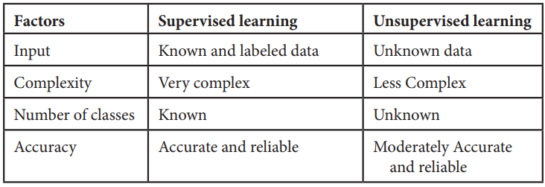
1. Supervised learning:
In supervised learning labelled dataset is used. Here the model is trained on labelled dataset. This dataset contains both input and output parameters. Supervised learning is learning where there is input data, output data and algorithm that maps to input and output.
Learning means input and output is provided to machine and machine will develop its own logic for the given task. Some supervised learning algorithms are: Linear Regression, Nearest Neighbour, Gaussian Naive Bayes, Decision Trees, Support Vector Machine (SVM), Random Forest, etc.
The learning is called supervised learning because it is similar to a teacher who is acting as supervisor on entire learning process. The predictions on trained data are generated by learning algorithms. These predictions are corrected by the teacher and learning process is stopped when correct output is achieved [5, 6].
2. Unsupervised learning:
Unsupervised learning is learning that contains only input data and no output data is present. This is applied where there is need to model data distribution in order to get more and more data and there is no any supervisor (like teacher) to supervised the things. Algorithms themselves learn, discover and present structure in data. Here algorithm itself create data pattern. Some recommendation systems for marketing automation use this type of learning.
3. Semi-supervised learning:
The supervised learning has disadvantage that it required labelled dataset. This process is very costly while dealing with large volume of data. Unsupervised learning also has disadvantage that the range of its application is limited.
To solve these problems, semi supervised learning algorithms concept was developed. This concept used both labelled data and unlabelled data so that it can work on any type of data. Mostly it contains small amount of labelled data and huge amount of unlabelled data.
1.4.2 Machine Learning Algorithms
There are various machine learning algorithms as described in Figure 1.1 below. These algorithms can be applied in any area to solve various problems.
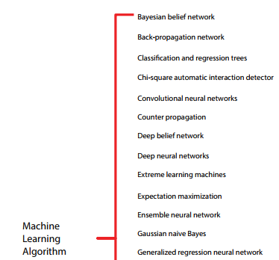
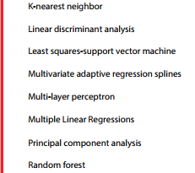
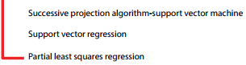
Figure1.2 Machine learning algorithms

CHAPTER 2
LITERATURE SURVEY
  - K Pujitha; Gorla Nandini; K V Teja Sree; Banda Nandini; Dhodla Radhika, “Cyber Hacking Breaches Prediction and Detection Using Machine Learning”, 2023 2nd International Conference on Vision Towards Emerging Trends in Communication and Networking Technologies (ViTECoN), IEEE Conference, 2023.
Cyber hacking breaches prediction is one of the emerging technologies and it has been a quite challenging task to recognize breaches detection and prediction using computer algorithms. Making malware detection more responsive, scalable, and efficient than traditional systems that call for human involvement is the main goal of applying machine learning for breaches detection and prediction. Various types of cyber hacking attacks any of them will harm a person's information and financial reputation. Data from governmental and non-profit organizations, such as user and company information, may be compromised, posing a risk to their finances and reputation. The information can be collected from websites that can trigger cyberattack. Organizations like the healthcare industry are able to contain sensitive data that needs to be kept discreet and safe. Identity theft, fraud, and other losses may be caused by data breaches. The findings indicate that 70% of breaches affect numerous organizations, including the healthcare industry. The analysis displays the likelihood of a data breach. Due to increased usage of computer applications, the security for host and network is leading to the risk of data breaches. Machine learning methods can be used to find these assaults. By research, machine learning models are utilized to protect the website from security flaws. The dataset can be obtained from the Privacy Rights Clearinghouse. Data breaches can be decreased by educating staff on the use of modern security measures. This can aid in understanding the attacks knowledge and data security. The machine learning models like Random Forest, Decision Tree, k-means and Multi-layer Perceptron are used to predict the data breaches. Over the years, corporations have increasingly become the target of cyberattacks. Among the ransomware that causes such severe damage, the hackers may employ many attack types. Today, maintaining system security, including the confidentiality of both corporate and personal data, is quite difficult. Millions of cyberattacks per day cause tremendous financial losses. Our study has three main objectives. Using actual cybercrime data, the initial phase is to predict a cybercrime strategy, and the accuracy results are then compared. The second is to examine if the information at hand can be used to predict cybercrime perpetrators. It is employed to hide a system's data. Information theft is caused by sensitive and highly confidential data as well as poor management. The hackers' techniques might be found in two different methods. One is to move through with legal action, get in touch with the victim, and let them know about the violations [1]. The organizations should be aware of the sorts, trends, and patterns of assaults for the purpose of enabling them to monitor the system. We present a study on the consequences of these kinds of attacks in an effort for managing the prevention of occurring the beaches. We provide comprehensive study of the breaches that have occurred by the various organizations and financial effect. Because of improvements in information technology, declining prices for memory and storage devices, and the expansion of the digital economy, businesses and governmental organizations now acquire more data every day. Businesses and organizations have the threat of data attacks because of the collecting of personal data on their computers. The Privacy Rights Clearinghouse (PRC) found a large number of records that were exposed due to data breaches between 2005 and 2019. The organization may face legal action as a result of data breaches that cause financial and reputational harm. Computer networks are used in manufacturing, healthcare, research. This information is transferring every second through network. These attacks are used for profit and destroy the important information and use that for own need which rises the risk of data [2]. Hybrid based detection is used to detect the high false positive rates and low false positive rates. Anomaly based detection analyzes the behavior of traffic, where signature-based detection has the previous attacks records and able to detect the possibilities.
  - M. Xu, K. M. Schweitzer, R. M. Bateman and S. Xu, "Modeling and predicting cyber hacking breaches", IEEE Trans. Inf. Forensics Security, vol. 13, no. 11, pp. 2856-2871, 2018.
Analyzing cyber incident data sets is an important method for deepening our understanding of the evolution of the threat situation. This is a relatively new research topic, and many studies remain to be done. In this paper, we report a statistical analysis of a breach incident data set corresponding to 12 years (2005-2017) of cyber hacking activities that include malware attacks. We show that, in contrast to the findings reported in the literature, both hacking breach incident inter-arrival times and breach sizes should be modeled by stochastic processes, rather than by distributions because they exhibit autocorrelations. Then, we propose particular stochastic process models to, respectively, fit the inter-arrival times and the breach sizes. We also show that these models can predict the inter-arrival times and the breach sizes. In order to get deeper insights into the evolution of hacking breach incidents, we conduct both qualitative and quantitative trend analyses on the data set. We draw a set of cybersecurity insights, including that the threat of cyber hacks is indeed getting worse in terms of their frequency, but not in terms of the magnitude of their damage.
  - S. Depuru, P. Hari, P. Suhaas, S. R. Basha, R. Girish and. K. Raju, "A Machine Learning based Malware Classification Framework," 2023 5th International Conference on Smart Systems and Inventive Technology (ICCSIT), Tirunelveli, India, 2023, pp. 1138-1143, doi:10.1109/ICSSIT55814.2023.10060914.
As cybersecurity threats become increasingly complex, there is a critical need for effective prediction systems to prevent cyber hacking breaches. This study introduces an innovative approach using Machine Learning, specifically the Random Forest Classifier, to predict potential cyber breaches based on URLs. Through extensive training and evaluation, the system demonstrated outstanding performance, achieving a training accuracy of 99% and a test accuracy of 91%. These results highlight the system's capability to identify patterns and differentiate between legitimate and malicious instances, offering a reliable tool for cybersecurity.
  - Naaz, Alsaba, Maivis Sheikh, Vaishnavi Narnaware, Sneha Chilkapure, and Kranti Bhatwalkar. "CYBER HACKING BREACHES PREDICTION AND DETECTION."
In an generation wherein cybersecurity threats have end up more and more sophisticated, the want for sturdy prediction and detection structures to guard in opposition to cyber hacking breaches is paramount. This mission affords a singular technique to deal with this concern, using Machine Learning techniques, in particular the Random Forest Classifier, to are expecting and locate ability cyber hacking breaches. Implemented in Python, the proposed device makes use of a cautiously curated dataset of 5457 URLs, encompassing 87 extracted features. Crucially, the dataset maintains a balanced composition, precisely divided between 50% phishing and 50% legitimate URLs. The project's number one consciousness lies in correctly figuring out cyber threats at the same time as minimizing fake positives. Through rigorous schooling and evaluation, the carried out consequences display the system's fantastic performance. The Random Forest Classifier attains a commendable training accuracy of 99%, ensuring its ability to discern patterns and distinguish between legitimate and malicious URLs. The version additionally showcases a sturdy take a look at accuracy of 91%, similarly validating its reliability in real-international scenarios. In conclusion, this challenge stands as a pioneering attempt withinside the realm of cyber hacking breach prediction and detection, harnessing the strength of Machine Learning and the Random Forest Classifier to offer enhanced security measures. The notable accuracy done serves as a testomony to its effectiveness, empowering agencies to give a boost to their cybersecurity defenses in opposition to capability cyber threats and attacks.
  - Reddy, A. Rama Swamy, and Talasila Alekhya. "Detection of Cyber Hacking Breaches using Machine Learning Algorithm." NeuroQuantology 20, no. 10 (2022): 1654.
Analyzing the data gathered from cyber events is crucial if we are to understand the present state of the threat environment. There are still a lot of unanswered questions in this field of study. Based on malware attacks that occurred between 2005 and 2017, we did a statistical analysis of the data. Contrary to popular belief, we discover that hacking violation case interarrival durations and violation dimensions must be created by stochastic processes, not circulatory systems, as previously thought. This is because of autocorrelations. As a next step, we present stochastic process models for inter-arrival times and violation dimensions. These designs can also forecast the intervals between arrivals and the sizes of violations. For a better understanding of how hacking incidents are progressing, we do both qualitative and quantitative trend assessments on the data set. A current understanding of cyber security shows an increase in the frequency and severity of cyber attacks without an increase in their size.

CHAPTER 3
EXISTING METHOD
3.1 Exiting work
"Cyber-Guard" is an innovative machine learning framework designed to anticipate and mitigate cyber-hacking breaches. In this Autoencoder is existing method. By leveraging the capabilities of Random Forest and Multi-Layer Perceptron (MLP) algorithms, it utilizes advanced pattern recognition and classification techniques to detect and prevent potential threats. The synergy between Random Forest's ensemble learning and MLP's deep neural network architecture allows Cyber-Guard to analyze complex data patterns accurately. Its adaptability and continuous learning ensure robust defense mechanisms against evolving cyber threats, making it a crucial tool for protecting critical systems and sensitive data.
3.2 Disadvantages Of Existing Method
- Limited to Known Threats: This method can only detect threats that have been previously identified and cataloged. New, unknown threats (zero-day attacks) go undetected.
- Difficult to Define Normal Behavior: In dynamic environments where behavior patterns frequently change, defining what constitutes normal behavior can be difficult.
- Difficult to Define Normal Behavior: In dynamic environments where behavior patterns frequently change, defining what constitutes normal behavior can be difficult.
- Complex to Implement: Developing accurate behavioral models requires significant effort and expertise.

CHAPTER 4
PROPOSED METHOD
4.1 Proposed Work
In an era where cybersecurity threats have become increasingly sophisticated, the need for robust prediction and detection systems to safeguard against cyber hacking breaches is paramount. This project presents a novel approach to address this concern, employing Machine Learning techniques, specifically the Random Forest Classifier ad MLP, to predict and detect potential cyber hacking breaches.
This project stands as a pioneering effort in the realm of cyber hacking breach prediction and detection, harnessing the power of Machine Learning and the Random Forest Classifier and MLP to offer enhanced security measures. The remarkable accuracy achieved serves as a testament to its effectiveness, empowering organizations to fortify their cybersecurity defenses against potential cyber threats and attacks.
Numerous machine learning models have been suggested for determining the likelihood of a cyber hack, yet none have sufficiently tackled the issue of misdiagnosis. Furthermore, similar studies focusing on evaluating classification performance often overlook the complexities of data heterogeneity and size, failing to provide comprehensive solutions

4.1.1 Model selection: Gather a comprehensive dataset containing information about past cyber hacking incidents. This dataset should include features such as time of attack, type of attack (e.g., phishing, malware, DDoS), target system or network, duration of attack, methods used, and any other relevant information.
4.1.2 Data preprocessing: When data is preprocessed, it is cleaned up by eliminating missing values and transformed into numerical representations for categorical variables using methods like label or one-hot encoding.
4.1.3 Feature engineering: Discover the critical features that play a vital role in forecasting hacking breaches by utilizing various methods, including correlation analysis, assessing feature importance through tree-based models, or leveraging domain expertise to cherry-pick or engineer novel features.
4.1.4 Model selection and training: Select the right machine learning algorithms for your classification jobs based on the challenge at hand and the characteristics of your data. to optimize hyperparameters, ensuring improved model performance.
4.1.5 Model evalution and selection: Examine the performance of multiple models using evaluation metrics and opt for the one exhibiting the highest performance on the validation set. Subsequently, validate the chosen model on the testing set to evaluate its capacity for generalization and verify its accuracy in predicting outcomes on new, unseen data.
4.1.6 datasets used Researchers and practitioners utilize a variety of datasets to forecast cyber hacking breaches; in this case, I'm using the datasets listed below.
4.6.7 Data breaches(2004-20021): This dataset includes various features related to cyber hacking incidents, such as attack type, target system, time of attack, duration, impact, attack vector, data breach details, regulatory compliance, industry sector, attack source, attack tools. It contain attributes like entity, organization type, records, year, method

4.2 Advantages of proposed work
- High Accuracy in Detection
- Robustness Against Overfitting
- Versatility in Handling Different Data Types
- Adaptability and Continuous Learning
- Feature Importance and Interpretability
- Early Detection
- Adaptive Analysis
- Pattern recognition
- Improved Incident Response
- Enhanced Risk Mitigation
4.3 Algorithms
4.3.1 Random Forest
The Random Forest algorithm is a robust tree-based learning method in Machine Learning. It constructs multiple decision trees during training, each built from a random subset of the dataset and features. This randomness introduces variability among the trees, reducing overfitting and enhancing overall predictive performance. For predictions, the algorithm aggregates the results from all trees, providing stable and precise outcomes. Random forests are widely used for both classification and regression tasks, known for handling complex data, reducing overfitting, and delivering reliable forecasts in diverse scenariosRandom forest is a commonly-used machine learning algorithm, trademarked by Leo Breiman and Adele Cutler, that combines the output of multiple decision trees to reach a single result.
Its ease of use and flexibility have fueled its adoption, as it handles both classification and regression problem. Random Forest is a powerful and versatile machine learning algorithm that is widely used for classification and regression tasks. It is an ensemble learning method, which means it constructs multiple decision trees during training and outputs the class that is the mode of the classes (classification) or mean prediction (regression) of the individual trees. Random Forest is a versatile and powerful machine learning algorithm that is widely used for both classification and regression tasks. It is an ensemble learning method, which means it combines multiple individual models to produce a stronger overall model. Random forests or random decision forests is an ensemble learning method for classification, regression and other tasks that operates by constructing a multitude of decision trees at training time. For classification tasks, the output of the random forest is the class selected by most trees. For regression tasks, the mean or average prediction of the individual trees is returned Random decision forests correct for decision trees' habit of overfitting to their training set.
The first algorithm for random decision forests was created in 1995 by Tin Kam Ho using the random subspace method,^{[2]} which, in Ho's formulation, is a way to implement the "stochastic discrimination" approach to classification proposed by Eugene Kleinberg. An extension of the algorithm was developed by Leo Breiman^{[7]} and Adele Cutler, who registered "Random Forests" as a trademark in 2006 (as of 2019, owned by Minitab, Inc.). The extension combines Breiman's "bagging" idea and random selection of features, introduced first by Ho and later independently by Amit and Geman in order to construct a collection of decision trees with controlled variance.
4.3.2 Multi-layer Perceptron:
The multi-layer perceptron (MLP) is another artificial neural network process containing a number of layers. In a single perceptron, distinctly linear problems can be solved but it is not well suitable for non-linear cases. To solve these complex problems, MLP can be considered. MLPs tend to generate higher yields than bonds and stocks due in part to the favorable tax structure. Most MLPs are listed on national exchanges and are therefore typically more liquid than traditional partnerships.
Multi-layer perception is also known as MLP. It is fully connected dense layers, which transform any input dimension to the desired dimension. A multi-layer perception is a neural network that has multiple layers. To create a neural network we combine neurons together so that the outputs of some neurons are inputs of other neurons. A multi-layer perceptron has one input layer and for each input, there is one neuron(or node), it has one output layer with a single node for each output and it can have any number of hidden layers and each hidden layer can have any number of nodes. A Multi-layer Perceptron (MLP) is a class of artificial neural network (ANN) that consists of multiple layers of nodes, with each layer fully connected to the next one. It is one of the foundational architectures in deep learning and is widely used for various tasks such as classification, regression, and pattern recognition.
A multilayer perceptron (MLP) is a name for a modern feedforward artificial neural network, consisting of fully connected neurons with a nonlinear activation function, organized in at least three layers, notable for being able to distinguish data that is not linearly separable. Modern feed forward networks are trained using the backpropagation method and are colloquially referred to as the "vanilla" neural networks. MLPs grew out of an effort to improve single-layer perceptrons, which could only distinguish linearly separable data. A perceptron traditionally used a Heaviside step function as its nonlinear activation function. However, the backpropagation algorithm requires that modern MLPs use continuous activation functions such as sigmoid or ReLU
4.3.3 Autoencoder
An autoencoder is a type of artificial neural network used to learn efficient codings of unlabeled data (unsupervised learning). An autoencoder learns two functions: an encoding function that transforms the input data, and a decoding function that recreates the input data from the encoded representation. An autoencoder is a type of artificial neural network used to learn efficient codings of unlabeled data (unsupervised learning).^{[1][2]} An autoencoder learns two functions: an encoding function that transforms the input data, and a decoding function that recreates the input data from the encoded representation. The autoencoder learns an efficient representation (encoding) for a set of data, typically for dimensionality reduction.
Variants exist, aiming to force the learned representations to assume useful properties.^{[3]} Examples are regularized autoencoders (Sparse, Denoising and Contractive), which are effective in learning representations for subsequent classification tasks,^{[4]} and Variational autoencoders, with applications as generative models.^{[5]} Autoencoders are applied to many problems, including facial recognition,^{[6]} feature detection,^{[7]} anomaly detection and acquiring the meaning of words.^{[8][9]} Autoencoders are also generative models which can randomly generate new data that is similar to the input data (training data).
Autoencoders are a specialized class of algorithms that can learn efficient representations of input data with no need for labels. It is a class of artificial neural networks designed for unsupervised learning. Learning to compress and effectively represent input data without specific labels is the essential principle of an automatic decoder. This is accomplished using a two-fold structure that consists of an encoder and a decoder. The encoder transforms the input data into a reduced-dimensional representation, which is often referred to as “latent space” or “encoding”. From that representation, a decoder rebuilds the initial input. For the network to gain meaningful patterns in data, a process of encoding and decoding facilitates the definition of essential features.

CHAPTER 5
METHODOLOGY
The complete system architecture can be described as the following components:
1. Data Collection and Preprocessing: It consists of data sources, data cleaning, and feature extraction.
2. Data Splitting: It divides the dataset into two sets, i.e., training and testing sets.
3. Machine Learning Model: Choosing a random forest classifier and then training the model using the training datasets.
4. Evaluation: It does the testing of the model’s performance.
5. Real-time Monitoring and Detection: Real-time monitoring and detection of cyber threats.
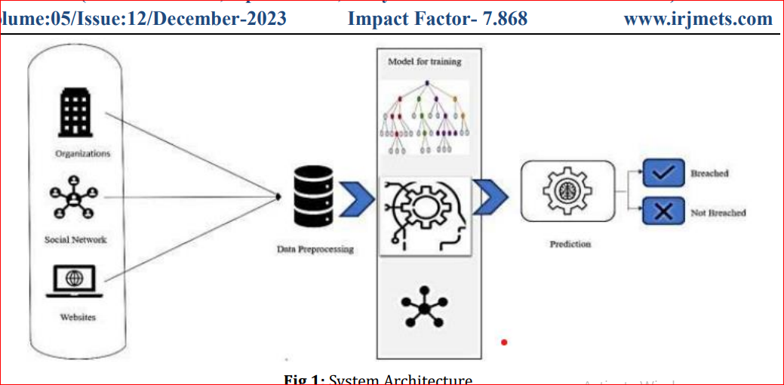
Fig 5.1: System Architecture

CHAPTER 6

SYSTEM REQUIREMENTS:

6.1 HARDWARE REQUIREMENTS:
- System : Pentium i3 Processor.
- Hard Disk : 500 GB.
- Monitor : 15’’ LED
- Input Devices : Keyboard, Mouse
- Ram : 6 GB

6.2 SOFTWARE REQUIREMENTS:
- Operating system : Windows 10 / 11.
- Coding Language : Python 3.10.9.
- Web Framework : Flask.
- Frontend : HTML, CSS, JavaScript.

CHAPTER 7
RESULT
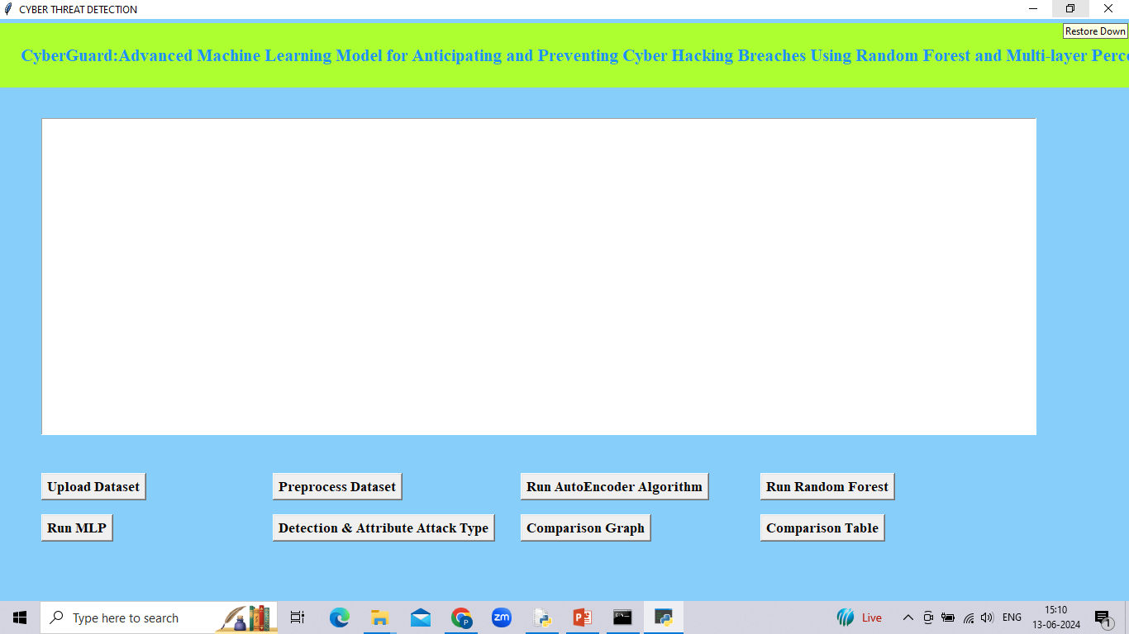
Fig.7.1 Upload Dataset
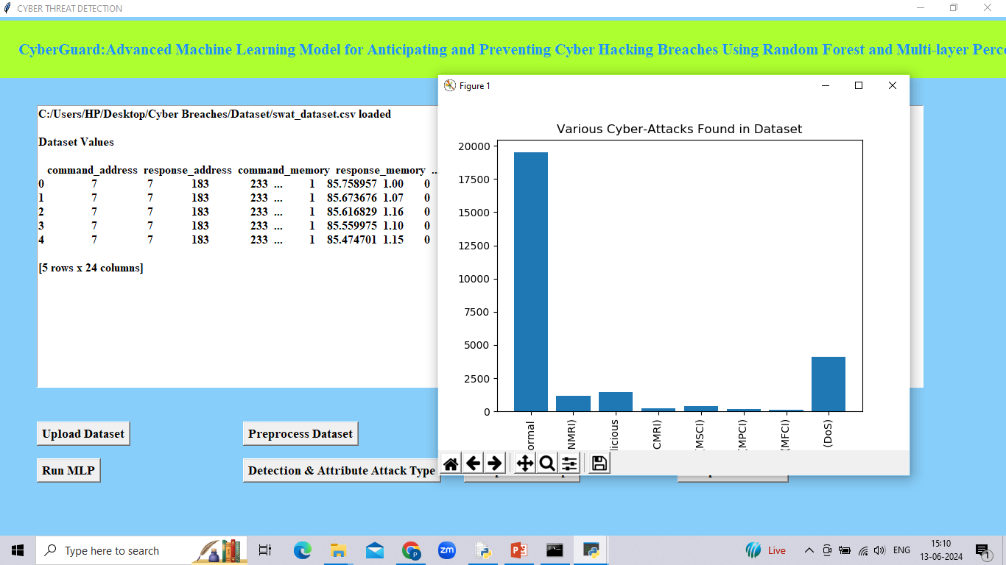
Fig.7.2 Data Preprocessing
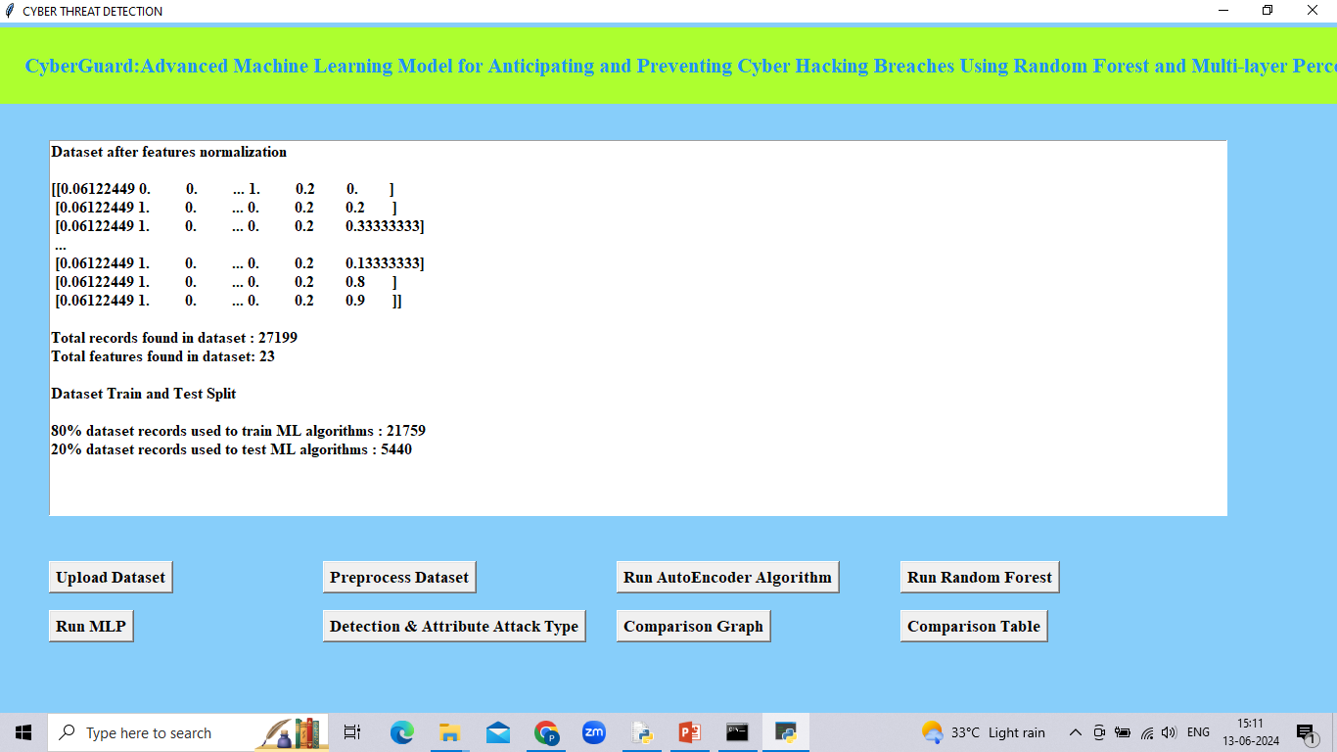
Fig.7.3 Dataset train and test
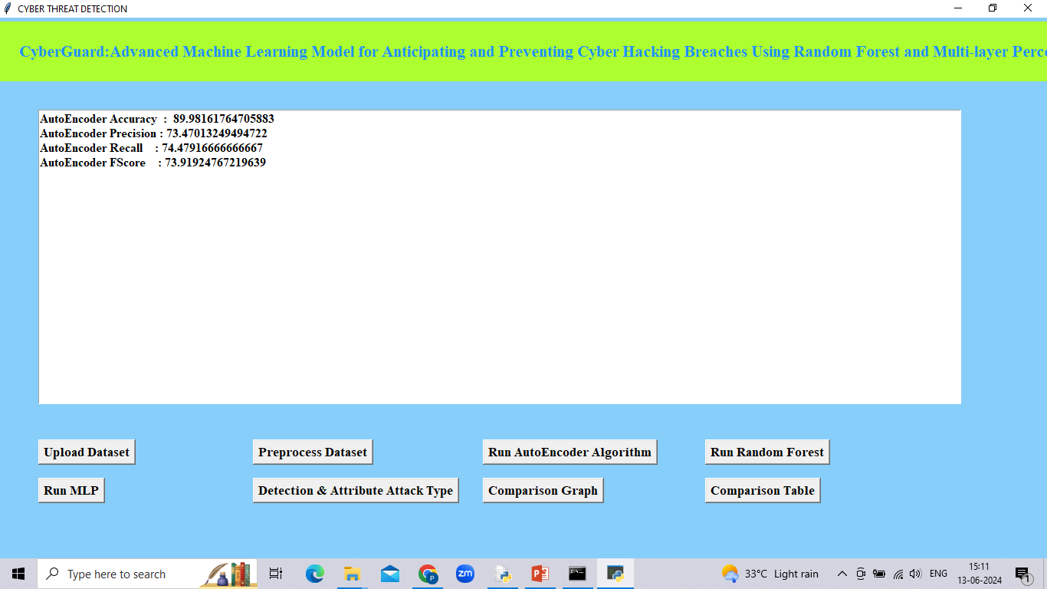
Fig.7.4 Auto Encoder
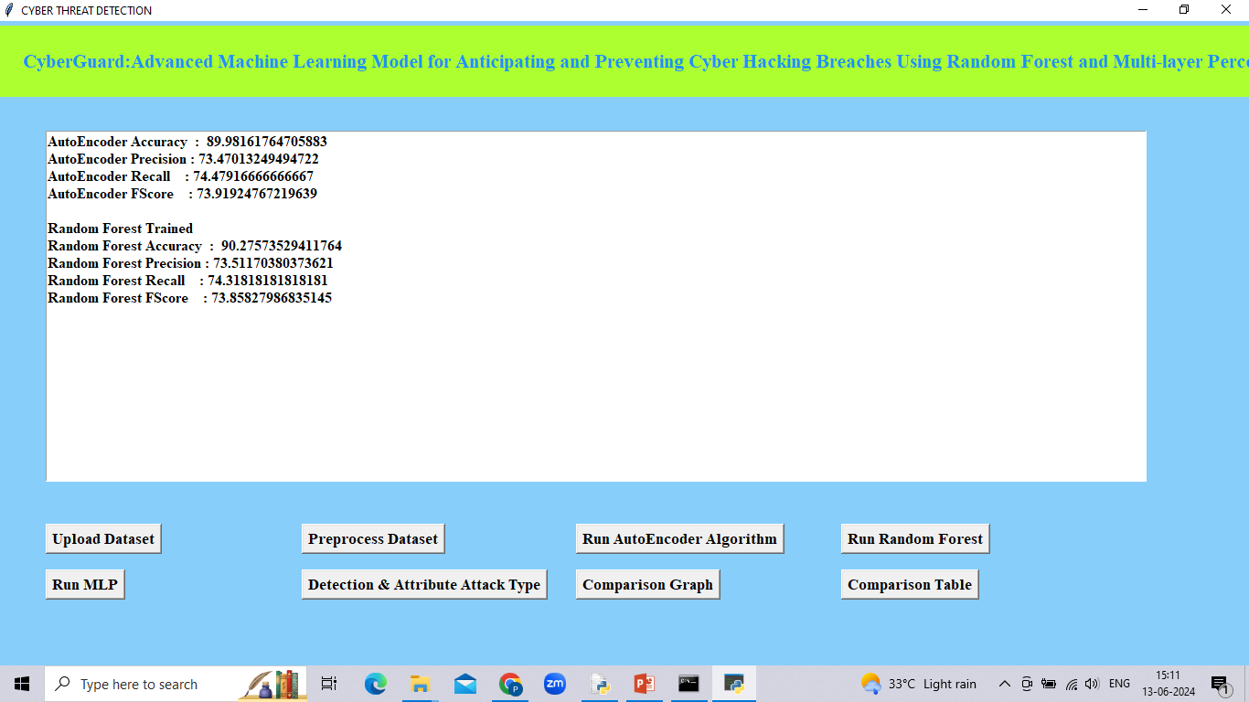
Fg.7.5 Random forest

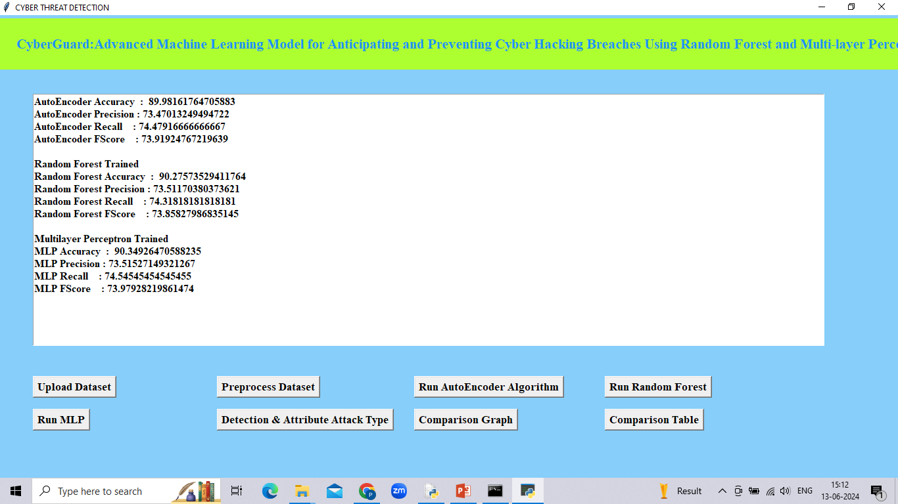
Fig.7.6 MLP

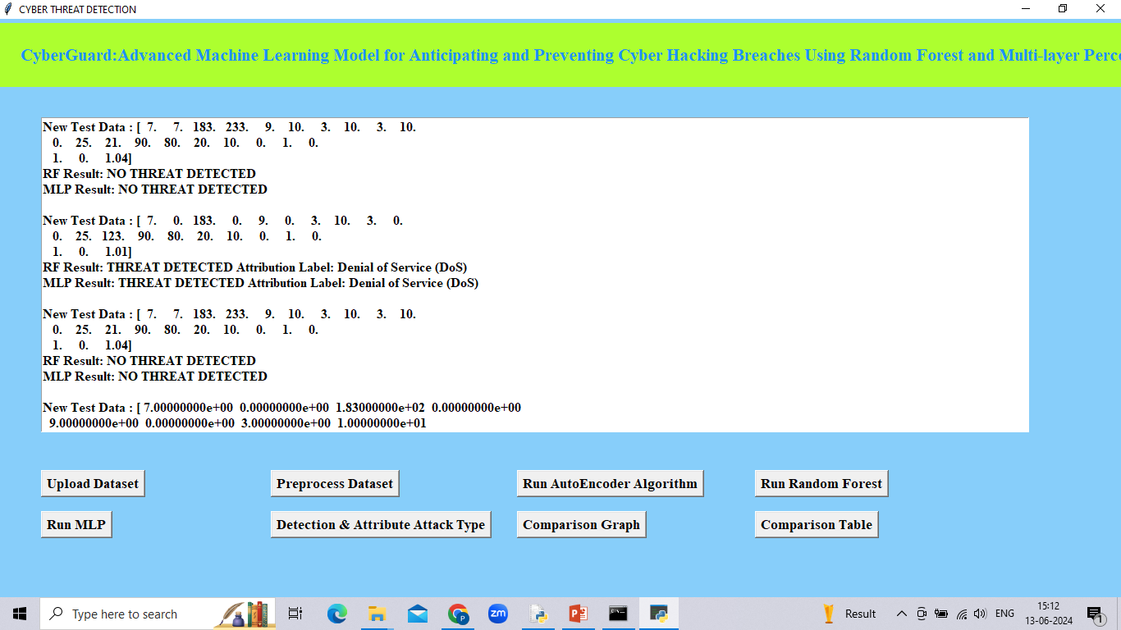
Fig.7.7 Threat Detection

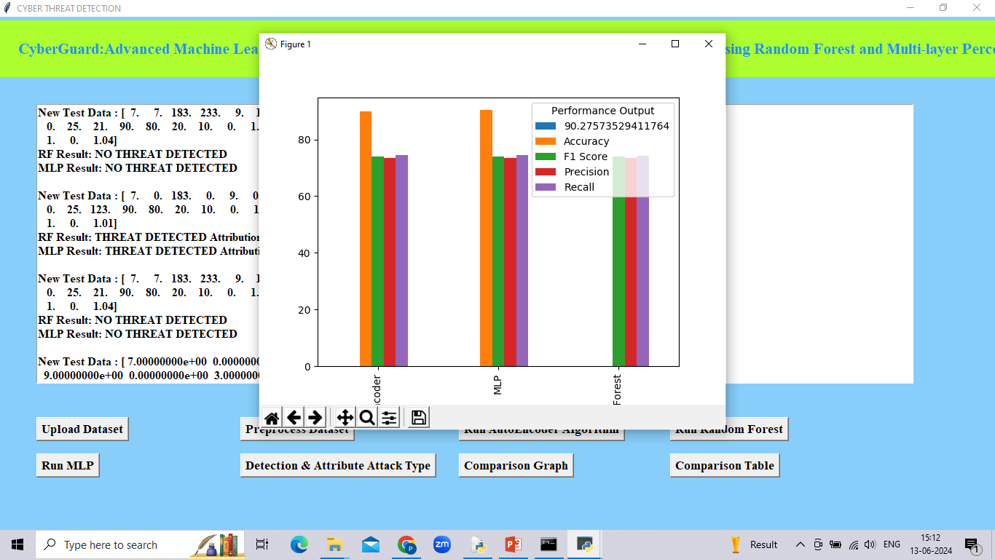
Fig.7.8 Algorithms Graph

CHAPTER 8
CONCLUSION AND FUTURE SCOPE
In summary, the integration of Random Forest (RF) and Multi-Layer Perceptron (MLP) algorithms are proposed algorithms to detect threat. This approach enhances detection accuracy, adapts to diverse data types, and fosters robust defense mechanisms against evolving cyber threats. By leveraging RF's ensemble learning for stability and MLP's deep learning for intricate pattern recognition, Cyber-Guard not only detects but also proactively mitigates potential breaches.
When you are part of an organization, whether you are an employee or a manager, one thing you may already have realized is that Time is the most essential part of the organization. From coming and leaving office on time to delivering projects or finishing tasks on time, the clock plays a very important role in our lives. Essentially that is the reason why almost all of the organizations have implemented attendance marking systems. Back in the days marking attendance was straight forward. You sign on a register every day when you enter the office premises. In larger organizations, it was an easy job to manipulate the register to falsify your actual working hours and entry time.

REFERENCES
  - K Pujitha; Gorla Nandini; K V Teja Sree; Banda Nandini; Dhodla Radhika, “Cyber Hacking Breaches Prediction and Detection Using Machine Learning”, 2023 2nd International Conference on Vision Towards Emerging Trends in Communication and Networking Technologies (ViTECoN), IEEE Conference, 2023.
  - M. Xu, K. M. Schweitzer, R. M. Bateman and S. Xu, "Modeling and predicting cyber hacking breaches", IEEE Trans. Inf. Forensics Security, vol. 13, no. 11, pp. 2856-2871, 2018.
  - S. Depuru, P. Hari, P. Suhaas, S. R. Basha, R. Girish and. K. Raju, "A Machine Learning based Malware Classification Framework," 2023 5th International Conference on Smart Systems and Inventive Technology (ICCSIT), Tirunelveli, India, 2023, pp. 1138-1143, doi:10.1109/ICSSIT55814.2023.10060914.
  - Naaz, Alsaba, Maivis Sheikh, Vaishnavi Narnaware, Sneha Chilkapure, and Kranti Bhatwalkar. "CYBER HACKING BREACHES PREDICTION AND DETECTION."
  - Reddy, A. Rama Swamy, and Talasila Alekhya. "Detection of Cyber Hacking Breaches using Machine Learning Algorithm." NeuroQuantology 20, no. 10 (2022): 1654.

  - K. Pujitha, Kattamanchi Prem Krishna, K. Amala, annnavarapu Yassine, Sivakumar 14 Depuru, K o p p a ram Run Vika, “Development of Secured Online Parking Spaces”, Journal of Pharmaceutical Negative Results, vol. 13, no. 4, pp. 1010–1013, Nov. 2022.
  - H. Hammouchi, O. Cherqi, G. Mezzour, M Ghogho, and M. El Koutbi, “Digging deeper into data breaches: An exploratory data analysis of hacking breaches overtime,” Procedia Computer Science, vol. 151, pp. 1004–1009, 2019.
  - Verizon, “Data breach investigations report,” 2019. [Online]. Available : https://enterprise.verizon.com/resources/reports/dbir/
  - M. Xu, K. M. Schweitzer, R. M. Bateman, and S. Xu Modeling and predicting cyber hacking breaches IEEE Trans. Inf. Forensics Security, vol. 13, no. 11, pp. 2856–2871, 2018.

APPENDIX
PYTHON
1.1 Introduction
* One of the most popular languages is Python. Guido van Rossum released this language in 1991. Python is available on the Mac, Windows, and Raspberry Pi operating systems. The syntax of Python is simple and identical to that of English. When compared to Python, it was seen that the other language requires a few extra lines.
*It is an interpreter-based language because code may be run line by line after it has been written. This implies that rapid prototyping is possible across all platforms. Python is a big language with a free, binary-distributed interpreter standard library.
* It is inferior to maintenance that is conducted and is straightforward to learn. It is an object-oriented, interpreted programming language. It supports several different programming paradigms in addition to object-oriented programming, including functional and procedural programming.
* It supports several different programming paradigms in addition to object-oriented programming, including practical and procedural programming. Python is mighty while maintaining a relatively straightforward syntax. Classes, highly dynamic data types, modules, and exceptions are covered. Python can also be utilised by programmes that require programmable interfaces as an external language.
Here are some key features and characteristics of Python:
- Readability: Python emphasizes code readability with its clean and intuitive syntax. It uses indentation and whitespace to structure code blocks, making it easy to understand and maintain.
- Easy to Learn: Python's simplicity and readability make it an excellent choice for beginners. Its straightforward syntax and extensive documentation make it accessible for newcomers to programming.
- Interpreted Language: Python is an interpreted language, meaning that it doesn't need to be compiled before running. The Python interpreter reads and executes the code directly, making the development process faster and more interactive.
- Cross-platform Compatibility: Python is available for major operating systems like Windows, macOS, and Linux. This cross-platform compatibility allows developers to write code once and run it on different platforms without modifications.
- Large Standard Library: Python comes with a vast standard library that provides ready-to-use modules and functions for various tasks. It covers areas such as file I/O, networking, regular expressions, databases, and more, saving developers time and effort.
- Extensible and Modular: Python supports modular programming, enabling developers to organize code into reusable modules and packages. Additionally, Python allows integrating modules written in other languages, such as C or C++, providing flexibility and performance optimizations.
- Wide Range of Libraries and Frameworks: Python has a vibrant ecosystem with numerous third-party libraries and frameworks. These libraries, such as NumPy, pandas, TensorFlow, and Django, extend Python's capabilities for specific domains, making it a powerful tool for diverse applications.
- Object-Oriented: Python supports object-oriented programming (OOP) principles, allowing developers to create and work with classes and objects. OOP provides a structured approach to code organization, promoting code reuse and modularity.
- Dynamic Typing: Python is dynamically typed, meaning variable types are determined at runtime. Developers do not need to declare variable types explicitly, which enhances flexibility and simplifies code writing.
1.2 Installation
To install Python on your computer, follow these basic steps:
- Step 1: Visit the Python website Go to the official Python website at https://www.python.org/.
- Step 2: Select the operating system Choose the appropriate installer for your operating system. Python supports Windows, macOS, and various Linux distributions. Make sure to select the correct version that matches your operating system.
- Step 3: Check which version of Python is installed; if the 3.7.0 version is not there, uninstall it through the control panel and
- Step 4: Install Python 3.7.0 using Cmd.
- Step 5: Install the all libraries that required to run the project
- Step 6: Run
1.3 Python Features:
- Easy: Because Python is a more accessible and straightforward language, Python programming is easier to learn.
- Interpreted language: Python is an interpreted language, therefore it can be used to examine the code line by line and provide results.
- Open Source: Python is a free online programming language since it is open-source.
- Portable: Python is portable because the same code may be used on several computer standard
- libraries: Python offers a sizable library that we may utilize to create applications quickly.
- GUI: It stands for GUI (Graphical User Interface)
- Dynamical typed: Python is a dynamically typed language, therefore the type of the value will be determined at runtime.
1.4 Python GUI (Tkinter)
- Python provides a wide range of options for GUI development (Graphical User Interfaces).
- Tkinter, the most widely used GUI technique, is used for all of them.
- The Tk GUI toolkit offered by Python is used with the conventional Python interface.
- Tkinter is the easiest and quickest way to write Python GUI programs.
- Using Tkinter, creating a GUI is simple.
- A part of Python's built-in library is Tkinter. The GUI programs were created.
- Python and Tkinter together give a straightforward and quick way. The Tk GUI toolkit's object-oriented user interface is called Tkinter.

Making a GUI application is easy using Tkinter. Following are the steps:
1) Install the Tkinter module in place.
2) The GUI applicatioMakeske the primary window
3) Include one or more of the widgets mentioned above in the GUI application.
4) Set up the main event loop such that it reacts to each user-initiated event.
Although Tkinter is the only GUI framework included in the Python standard library, Python includes a GUI framework. The default library for Python is called Tkinter. Tk is a scripting language often used in designing, testing, and developing GUIs. Tk is a free, open-source widget toolkit that may be used to build GUI applications in a wide range of computer languages.

1.5 Python IDLE
- Python IDLE offers a full-fledged file editor, which gives you the ability to write and execute Python programs from within this program. The built-in file editor also includes several features, like code completion and automatic indentation, that will speed up your coding workflow.
- Guido Van Rossum named Python after the British comedy group Monty Python while the name IDLE was chosen to pay tribute to Eric Idle, who was one of the Monty Python's founding members. IDLE comes bundled with the default implementation of the Python language since the 01.5. 2b1 release
- IDLE is used to execute statements similar to Python Shell. IDLE is used to create, modify, and execute Python code. IDLE provides a fully-featured text editor to write Python scripts and provides features like syntax highlighting, auto-completion, and smart indent.
- IDLE has two modes: interactive and script. We wrote our first program, “Hello, World!” in interactive mode. Interactive mode immediately returns the results of commands you enter into the shell. In script mode, you will write a script and then run it.
- The IDE Python IDLE is a good place to start as it helps you become familiar with the way Python works and understand its syntax. This IDE is good to start programming in Python due to its great debugger, but once you are fluent and start developing projects it is necessary to jump to another, more complete IDE.
- Python IDLE (Integrated Development and Learning Environment) is an interactive development environment included with the Python programming language. It provides a convenient way to write, execute, and debug Python code.
When you install Python, IDLE is typically installed along with it. To open IDLE, you can follow these steps:
- Open the command prompt (Windows) or terminal (macOS/Linux).
- Type "idle" and press Enter. Alternatively, you can specify the version with "idle3" or "idle2" for Python 3 or Python 2, respectively.
- Once IDLE is launched, you will see the Python shell, which is an interactive environment where you can type and execute Python code directly.
Here are some features and functionalities provided by Python IDLE:
- Editor: IDLE includes a text editor where you can write your Python code. It offers syntax highlighting, automatic indentation, and code completion to enhance your coding experience.
- Interactive Shell: The Python shell in IDLE allows you to execute Python code interactively. You can type commands, statements, or function calls directly in the shell, and Python will execute them immediately.
- Debugging: IDLE provides basic debugging capabilities to help you find and fix errors in your code. You can set breakpoints, step through code, inspect variables, and track the program's execution.
- Python Help: IDLE provides access to the Python documentation and built-in help. You can access the help menu to find information about Python modules, functions, classes, and more.
- Script Execution: In addition to the interactive shell, IDLE allows you to run Python scripts stored in files. You can write your code in the editor and execute it as a script to see the output or interact with the program.
- Customization: IDLE can be customized to suit your preferences. You can modify settings related to syntax highlighting, indentation, fonts, and more.
- Python IDLE serves as a beginner-friendly development environment and learning tool. It is suitable for writing small scripts, testing code snippets, experimenting with Python features, and learning the language's basics. However, for more advanced development projects, you may consider using other code editors or integrated development environments (IDEs) that provide additional features and better project management capabilities.
1.6 Libraries
In Python, libraries (also referred to as modules or packages) are collections of pre-written code that provide additional functionality and tools to extend the capabilities of the Python language. Libraries contain reusable code that developers can leverage to perform specific tasks without having to write everything from scratch.
Python libraries are designed to solve common problems, such as handling data, performing mathematical operations, interacting with databases, working with files, implementing networking protocols, creating graphical user interfaces (GUIs), and much more. They provide ready-to-use functions, classes, and methods that simplify complex operations and save development time.
Libraries in Python offer various advantages:
- Code Reusability:
- Efficiency:
- Collaboration
- Domain-Specific Functionality
- To use a Python library, you need to install it first.
There are some libraries following:
- Pandas:
Pandas are a Python computer language library for data analysis and manipulation. It offers a specific operation and data format for handling time series and numerical tables. It differs significantly from the release3-clause of the BSD license. It is a well-liked open-source of opinion that is utilized in machine learning and data analysis.
Pandas are a Python package providing fast, flexible, and expressive data structures designed to make working with “relational” or “labeled” data both easy and intuitive. It aims to be the fundamental high-level building block for doing practical, real-world data analysis in Python. Pandas are a Python library used for working with data sets.
- It has functions for analysing, cleaning, exploring, and manipulating data.
- The name "Pandas" has a reference to both "Panel Data", and "Python Data Analysis" and was created by Wes McKinney in 2008.
- Pandas allow us to analyse big data and make conclusions based on statistical theories.
- Pandas can clean messy data sets, and make them readable and relevant.
Relevant data is very important in data science. Pandas are a Python library for data analysis. Started by Wes McKinney in 2008 out of a need for a powerful and flexible quantitative analysis tool, pandas have grown into one of the most popular Python libraries. It has an extremely active community of contributors. The name is derived from the term "panel data", an econometrics term for data sets that include observations over multiple time periods for the same individuals. Its name is a play on the phrase "Python data analysis" itself.
- NumPy:
The NumPy Python library for multi-dimensional, big-scale matrices adds a huge number of high-level mathematical functions. It is possible to modify NumPy by utilizing a Python library. Along with line, algebra, and the Fourier transform operations, it also contains several matrices-related functions.
NumPy can be used to perform a wide variety of mathematical operations on arrays. It adds powerful data structures to Python that guarantee efficient calculations with arrays and matrices and it supplies an enormous library of high-level mathematical functions that operate on these arrays and matrices.
- NumPy is a Python library used for working with arrays.
- It also has functions for working in domain of linear algebra, Fourier transform, and matrices.
- NumPy was created in 2005 by Travis Oliphant. It is an open source project and you can use it freely.
- NumPy stands for Numerical Python.
- In Python we have lists that serve the purpose of arrays, but they are slow to process.
- NumPy aims to provide an array object that is up to 50x faster than traditional Python lists.
- The array object in NumPy is called ndarray, it provides a lot of supporting functions that make working with ndarray very easy.
- Arrays are very frequently used in data science, where speed and resources are very important.

- Matplotlib:
It is a multi-platform, array-based data visualization framework built to interact with the whole SciPy stack. MATLAB is proposed as an open-source alternative. Matplotlib is a Python extension and a cross-platform toolkit for graphical plotting and visualization.
Matplotlib is a popular Python library for creating static, animated, and interactive visualizations. It provides a flexible and comprehensive set of tools for generating plots, charts, histograms, scatter plots, and more. Matplotlib is widely used in various fields, including data analysis, scientific research, and data visualization.
Here are some key features and functionalities of the Matplotlib library:
- Plotting Functions
- Customization Options
- Multiple Interfaces
- Integration with NumPy and pandas
- Subplots and Figures:
- Saving and Exporting

- Scikit-learn:
The most stable and practical machine learning library for Python is scikit-learn. Regression, dimensionality reduction, classification, and clustering are just a few of the helpful tools it provides through the Python interface for statistical modeling and machine learning. It is an essential part of the Python machine learning toolbox used by JP Morgan. It is frequently used in various machine learning applications, including classification and predictive analysis.
Scikit-learn (also referred to as sklearn) is a widely used open-source machine learning library for Python. It provides a comprehensive set of tools and algorithms for various machine learning tasks, including classification, regression, clustering, dimensionality reduction, model selection, and pre-processing.
Here are some key features and functionalities of the Scikit-learn library:
- Easy-to-Use Interface:
- Broad Range of Algorithms:
- Data Pre-processing and Feature Engineering:
- Model Evaluation and Validation:
- Integration with NumPy and pandas:
- Robust Documentation and Community Support:

- Keras:
* Google's Keras is a cutting-edge deep learning API for creating neural networks. It is created in Python and is designed to simplify the development of neural networks. Additionally, it enables the use of various neural networks for computation. Deep learning models are developed and tested using the free and open-source Python software known as Keras.
Keras is a high-level deep learning library for Python. It is designed to provide a user-friendly and intuitive interface for building and training deep learning models. Keras acts as a front-end API, allowing developers to define and configure neural networks while leveraging the computational backend engines, such as Tensor Flow or Theano.
Here are some key features and functionalities of the Keras library:
- User-Friendly API
- Multi-backend Support
- Wide Range of Neural Network Architectures
- Pre-trained Models and Transfer Learning:
- Easy Model Training and Evaluation:
- GPU Support:

- h5py:
* The h5py Python module offers an interface for the binary HDF5 data format. Thanks to p5py, the top can quickly halt the vast amount of numerical data and alter it using the NumPy library. It employs common syntax for Python, NumPy, and dictionary arrays.
h5py is a Python library that provides a simple and efficient interface for working with datasets and files in the Hierarchical Data Format 5 (HDF5) format. HDF5 is a versatile data format commonly used for storing and managing large volumes of numerical data.
Here are some key features and functionalities of the h5py library:
  - HDF5 File Access
  - Dataset Handling:
  - Group Organization:
  - Attributes:
  - Compatibility with NumPy
  - Performance

- Tensor flow
TensorFlow is a Python library for fast numerical computing created and released by Google. It is a foundation library that can be used to create Deep Learning models directly or by using wrapper libraries that simplify the process built on top of TensorFlow. TensorFlow is an end-to-end open source platform for machine learning. TensorFlow is a rich system for managing all aspects of a machine learning system; however, this class focuses on using a particular TensorFlow API to develop and train machine learning models.
TensorFlow is a popular open-source library for machine learning and deep learning. It provides a comprehensive set of tools, APIs, and computational resources for building and training various types of machine learning models, especially neural networks.
Here are some key features and functionalities of TensorFlow:
- Neural Network Framework:
- Computational Graphs
- Automatic Differentiation
- GPU and TPU Support
- Distributed Computing
- Deployment Capabilities

- Tkinter
Tkinter is an acronym for "Tk interface". Tk was developed as a GUI extension for the Tcl scripting language by John Ousterhout. The first release was in 1991. Tkinter is the de facto way in Python to create Graphical User interfaces (GUIs) and is included in all standard Python Distributions. In fact, it's the only framework built into the Python standard library.
Tkinter is a standard Python library used for creating graphical user interfaces (GUIs). It provides a set of modules and classes that allow you to develop interactive and visually appealing desktop applications.
Here are some key features and functionalities of Tkinter:
- Cross-Platform Compatibility
- Simple and Easy-to-Use
- Widgets and Layout Management
- Event-Driven Programming
- Customization and Styling
- Integration with Other Libraries

- NLTK
NLTK is a toolkit build for working with NLP in Python. It provides us various text processing libraries with a lot of test datasets. A variety of tasks can be performed using NLTK such as tokenizing, parse tree visualization, etc NLTK (Natural Language Toolkit) is the go-to API for NLP (Natural Language Processing) with Python. It is a really powerful tool to pre-process text data for further analysis like with ML models for instance. It helps convert text into numbers, which the model can then easily work with.
NLTK (Natural Language Toolkit) is a Python library widely used for working with human language data and implementing natural language processing (NLP) tasks. It provides a set of tools, corpora, and resources for tasks such as tokenization, stemming, tagging, parsing, sentiment analysis, and more.
Here are some key features and functionalities of NLTK:
- Text Processing
- Part-of-Speech Tagging
- Named Entity Recognition
- Chunking and Parsing
- Sentiment Analysis:
- WordNet Integration:

- Scipy
SciPy is a collection of mathematical algorithms and convenience functions built on the NumPy extension of Python. It adds significant power to the interactive Python session by providing the user with high-level commands and classes for manipulating and visualizing data.
SciPy is a powerful scientific computing library for Python that provides a wide range of mathematical algorithms and functions. It builds upon NumPy, another fundamental library for numerical computing, and extends its capabilities by adding additional tools for scientific and technical computing tasks.
Here are some key features and functionalities of SciPy:
- Numerical Integration:
- Optimization and Root Finding
- Linear Algebra
- Signal and Image Processing
- Statistics

